**Project Part**: 3

**Date**: October 9th 2020

**Team Members**: Joseph Drahos, Rod Izadi

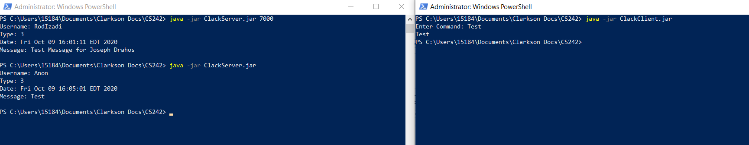

**Figure 1**: Test 1, Running .jar file with no arguments

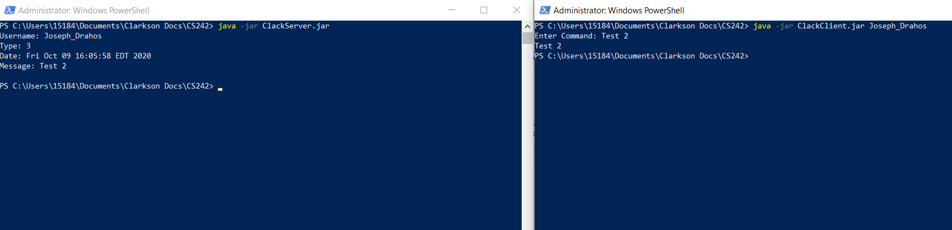

**Figure 2**: Test 2, running .jar file with username argument only  
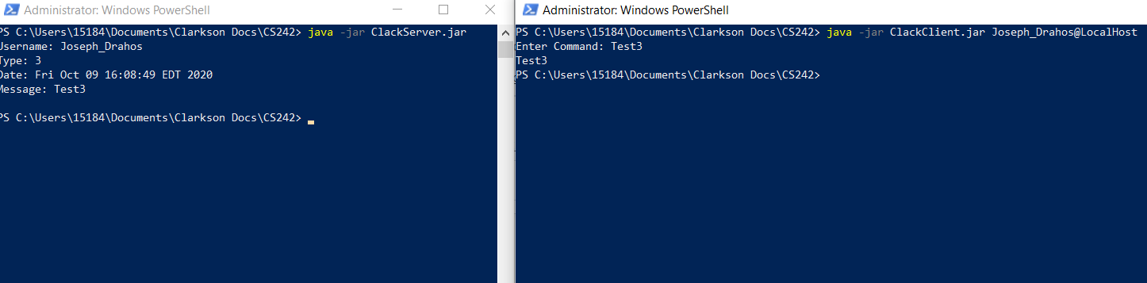

**Figure 3**: Test 3, running .jar file with username and hostname arguments

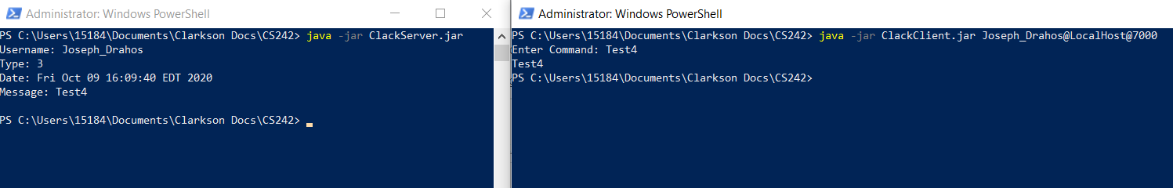

**Figure 4**: Test 4, running .jar file with username, hostname, and port arguments

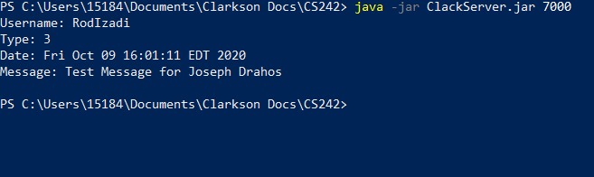

**Figure 5**: Server response from remote connection



**Figure 6**: Remote client connection

**Jar Files**:

